PROPOSAL TEMPLATE
Granting Program to Support Phragmites Adaptive Management
2026 REQUEST FOR GRANT PROPOSALS
Deadline: Wednesday, April 15, 2026 at 5:00 p.m. Eastern

Instructions:

Use this template to prepare your application for the PAMF Request for Proposals (RFP) https://www.greatlakesphragmites.net/pamf/aamp-funding/. Delete all instructional text in purple. Note that this template is meant for use as a guide, please refer to the RFP for all proposal requirements.71

Formatting: Proposals must be five pages or less (not including budget and attachments) with the exception of an additional page allowed per additional management unit. For example, proposals with six unique management units proposed are allowed 10 pages total. Shorter proposals are strongly encouraged. Proposals must be formatted with standard 1” margins, 12-point black font, and single-spaced.

PAMF Active Adaptive Management Program Grant Proposal

- Proposal Narrative

- Project Title and Abstract:

Provide a descriptive title for the proposed project (including the state/Native lands where the project will take place) and a one-paragraph abstract summarizing the proposal (including number of management units and priority management combination(s) selected). Indicate the management combination by its number and full name from the table in the BACKGROUND section (e.g., “#1-Glyphosate, Pre-Flood Clearing, Flood).”

- Applicant Information:

Name, address, and contact numbers for the applicant, including the primary contact (name, phone number, and email address).

- Applicant Background:

Brief description of the applicant (e.g., type of organization, nonprofit status).

- Statement of Qualifications:

Summarize the applicant’s professional experience as it relates to the general selection criteria listed.

- Work Plan:

Explain how the project will align with the goals and protocols of the Phragmites Adaptive Management Framework and specify which priority management combination(s) will be used to manage Phragmites. Indicate the management combination by its number and full name from the table in the BACKGROUND section (e.g., “#1-Glyphosate, Pre-Flood Clearing, Flood).” Specify willingness for participation in optional management activities (see Eligible Activities under the GRANT SPECIFICATIONS section). Include details of any associated communication plans.

- Project Location(s):

Activities must take place within areas invaded by non-native Phragmites including but not limited to wetlands, shorelines, riparian zones, roadsides, drainage areas, etc. Preference will be given to applicants that can show direct benefit to the Great Lakes. Activities do not need to take place within the Great Lakes basin to apply for this funding, so long as proposed activities and locations contribute substantially to the management of Phragmites in the Great Lakes basin. A map of the basin boundaries is available online: https://arcg.is/1eP1LK0

Satellite map (or similar) of each management unit to be enrolled and managed. If planning multiple management combinations, indicate which management combination will be used on which management units. In your map(s), include the following:
- The name you will use to identify the management unit (e.g., “Crossroads Patch 1”, “XYZ Park”) either placed directly on the map or nearby in the narrative. When naming your management units, please use a descriptive name (e.g., “XYZ Park – Parking lot”, “XYZ Park – Pond”, “ABC Wildlife Refuge N”, “ABC Wildlife Refuge S”) rather than simply “Management unit 1.” Avoid numbering your management units as that makes it easy to mix up locations.
- A boundary line drawn to surround the management unit (the entire area over which you will be able to uniformly manage Phragmites).
- An indication of scale, such as a scale bar. Narrative or map must also include an estimate of the management unit’s area (i.e., acres, hectares, square meters).
- An indication of the location within the surrounding landscape, e.g., the latitude/longitude of the site, and/or nearby cross streets, cities, or other landmarks.

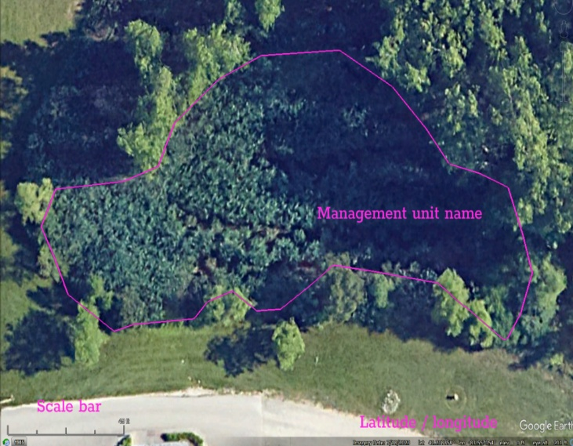
Example map (right) and caption:

Figure X. Management Unit Name, Area: XX hectares/acres/m²/etc. List of crossroads/ nearby cities/ center latitude/longitude, etc.

Justification for activities outside the Great Lakes basin: Activities outside of the Great Lakes basin can be justified via a justification. Example justification: Lake XYZ in ABC County, which is immediately outside of the Great Lakes basin, has an established population of non-native Phragmites that is at risk of spreading into the basin proper.
- Project Outcomes:

Describe the outcomes from the proposed project and connection to broader land use / management / restoration goals.

- Permits/ Land Use Approval:

Written documentation of landowner approval and any required land use permits. Any planned management actions that require permits and/or certifications (e.g., herbicide application) should outline the plan for securing the required permits and include proof of necessary certifications. Knowledge and acquisition of required permits is the responsibility of the grantee. Copies of permits and landowner approvals can be added as attachments at the end of the proposal (see Section C. Attachments below).

- Project Team:

Names of the individuals who will conduct the work, including contractors; their specific responsibilities; and the approximate amount of time they will devote to the project. For seasonal staff or other staff who are not yet hired but will work on this project, include the staff member’s position/title, “TBD”, and a description of responsibilities and hours for the staff member.

If desired, this could be provided as a table, for example:
Staff member | Responsibilities | Hours devoted to project
<Staff member name, title> | <List of general responsibilities> | <# hours>
Phraggy Phraggerson, CEO | Grant administration | 30 hours
Reed O’Plenty – Contractor, “Reed’s Contracting Co.” | Monitoring, sample collection, spading Phragmites | 100 hours
Seasonal Staff #1, TBD | Monitoring, outreach to public | 20 hours

- Project Schedule:
Indicate the work plan tasks in a timeline format for the project period of July 1, 2026 – July 31, 2027 and any prior required activities. Schedule should include time for collection of leaf samples for genetic testing, training, monitoring (July 2026 and July 2027), and management actions that will occur during the Translocating Phase (August – October), Dormant Phase (November – March), and Growing Phase (April – June).

When preparing your project schedule, consider the following dates and deadlines (you are not required to list each date, but use these as a reference for timing of your activities):
- June 15: Collect and submit leaf samples for genetic testing.
- Prior to monitoring in July: Enroll management unit (s; “MU”) in the PAMF online Web Hub and complete the AAMP Participant Training Moodle course (bit.ly/AAMP-Training) before you monitor!
- July 1–31, 2026 – Time to conduct monitoring of each enrolled MU.
- July 31, 2026 – Monitoring report #1 due for each enrolled MU.
- Post-monitoring to October 31, 2026 – Translocating phase when one management action type should be performed per MU.
- November 1, 2026 – Translocating phase management report due for each enrolled MU. Note that management actions must occur after monitoring.
- November 1, 2026 to March 31, 2027 – Dormant phase when one management action type should be performed per MU.
- February 15, 2027 – Semiannual financial report of expenses between July 1, 2026 and January 31, 2027 due.
- April 1, 2027 – Dormant phase management report due for each enrolled MU.
- April 1, 2027 to June 30, 2027 – Growing phase when one management action type should be performed per MU. Note that management activities must conclude at least one month before monitoring in July.
- July 1, 2027 – Growing phase management report due for each enrolled MU.
- July 1–31, 2027 – Time to conduct monitoring of each enrolled MU.
- July 31, 2027 – Monitoring report #2 due for each enrolled MU; conclusion of grant activities.
- August 30, 2027 – Latest submission of final reports and grant deliverables.

- Commitment to Genetic Testing:

Genetic testing of Phragmites in the proposed management unit is required by all applicants to ensure that grant funds will be used to manage non-native Phragmites australis subsp. australis. Award fund distribution is conditional on genetic verification of non-native Phragmites subspecies. Genetic testing services will be provided at no cost to all selected grantees. Provide a general statement about your commitment to collecting and submitting Phragmites samples for genetic testing by June 15 or leave this statement and check the box:

☐ The project team commits to collecting and submitting Phragmites leaf samples for genetic testing by June 15, 2026.

- Commitment to Obtain Insurance:

Successful applicants must agree to obtain, provide, and maintain liability and other insurance coverages at not less than the levels indicated (see Section B. Project Budget - Insurance). Provide a general statement about your commitment to obtaining the required insurance upon acceptance of grant funds or leave this statement and check this box:

☐ The project team commits to obtaining the required insurance upon acceptance of grant funds and providing documentation of insurance to AAMP administrators.

- Commitment to Execute Contract in a Timely Manner:

Successful applicants must agree to obtain, to sign and provide all necessary contracting materials within one month of receipt of contract from GLC. Those applicants who require a longer internal review process must indicate as such in their proposal. Provide a general statement about your commitment to the timely execution of the contract and check this box:

☐ The project team commits to signing and providing all necessary contracting materials within one month of receipt of contract from GLC.

B. Project Budget

Proposals must use the budget template below to itemize the following project costs, as described:

- Salaries: For each member of the project team, please specify title, number of hours, and hourly rate. An additional 10 – 15 hours per management unit should be included in salaries to cover participating in the required PAMF activities including initial training, collection of monitoring data, and submitting required PAMF reports.
- Fringe benefits: No formal limit on the rate of fringe benefits is established; however, the Great Lakes Commission (GLC) reserves the right to request documentation of fringe benefit rate calculations.
- Indirect costs: Grantees with a Negotiated Indirect Cost Rate Agreement (NICRA) may charge up to 25% of salaries and benefits (which is the indirect rate limit set by this funding opportunity). Please include your entity’s cost rate agreement with your proposal documents. Those without a NICRA can charge 15% of modified total direct costs (MTDC), which is the current de minimus rate set by the OMB Uniform Guidance.
- Contracts: There are limits to costs for consultants or other contract work. The federal government caps the rate allowed for individual consultants, and consultant expenses exceeding these caps will not be allowed.
- Direct costs: Other eligible costs such as project supplies (management materials), staff/volunteer refreshments, etc. Please itemize and provide calculations for costs when applicable. Costs for “refreshments” are limited under this RFP to those necessary to ensure health and safety of staff and volunteers assisting with events in approved work plan. Previously supported capital purchases funded under prior RFP cycles will be reviewed and considered.
- Travel: Please provide a justification for the amount of travel funds requested, including event dates and location, number of travelers, mileage, etc., to the best of your ability. Mileage expenses are limited to federal per diem and mileage rates.
- Equipment: Equipment (costing $5,000 or greater) is not an eligible cost under this funding opportunity.
- Outreach supplies: Expenses towards outreach are limited to 10% or $1,000 of the proposal budget. This includes expenses for materials such as signage, printouts, or other materials used for public outreach and education on Phragmites management. All outreach materials are subject to review prior to approval.

Note that once a grant award is made, any unspent funds that may remain at the end of the grant period will not be reimbursed and must be returned to the GLC. Further, once an award is made, any budget change greater than $1,000 per line item or 15 percent overall will require prior and written approval by the GLC.

BUDGET CATEGORIES | AMOUNT
- PERSONNEL SALARIES: (Include name, title, hours, and hourly rate)
Subtotal:
- FRINGE BENEFITS:
Subtotal:
- INDIRECT COSTS: (Indicate rate calculation; maximum rate is 25% of salaries and benefits)
Subtotal:
- DIRECT COSTS: (Supplies)
Subtotal:
- CONTRACTUAL SERVICES: (Provide names of contractors and rates)
Subtotal:
- OTHER: (Itemize; this includes project supplies, etc. in excess of the materials to be provided)
Subtotal:
- TRAVEL:
Subtotal:
TOTAL REQUESTED FUNDS:

C. Attachments

Attachments do not count toward the page limit and can include permits, proof of necessary certifications, land use approvals, etc. Letters of support from other local partners are encouraged. Optional supporting documents will only be reviewed as they relate to the contents of the proposal and will not be considered as part of the proposal evaluation.

